1. Click on the second icon from the left

Level of difficulty:   
Estimated time: 5 mn

[**www.codapps.io**](http://www.codapps.io)by Clement Levallois **@codapps_io** [**www.coursera.org/learn/codapps**](http://www.coursera.org/learn/codapps)



**Module 1: Installation of useful tools for the course**

*Creating your first project and previewing your app*

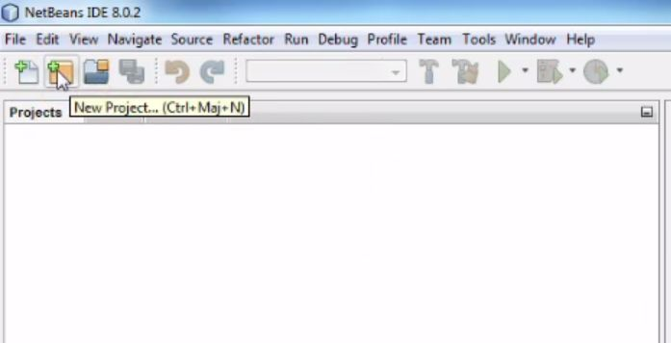

1. Select a « CodenameOne project »

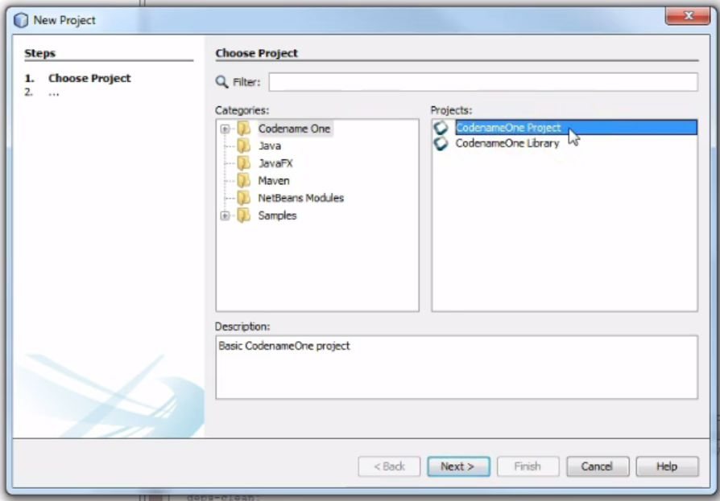

1. Choose a name for your project

Level of difficulty:   
Estimated time: 5 mn

**Module 1: Installation of useful tools for the course**

*Creating your first project and previewing your app*

No special characters like - _# »& @

**No accent marks like é ù à or ñ**

This will be the name of your app on the app store so please choose it carefully !

In this course, we start by building an app showing your curriculum vitae.

An idea for the name of your app would be « FirstName LastName Mobile CV »

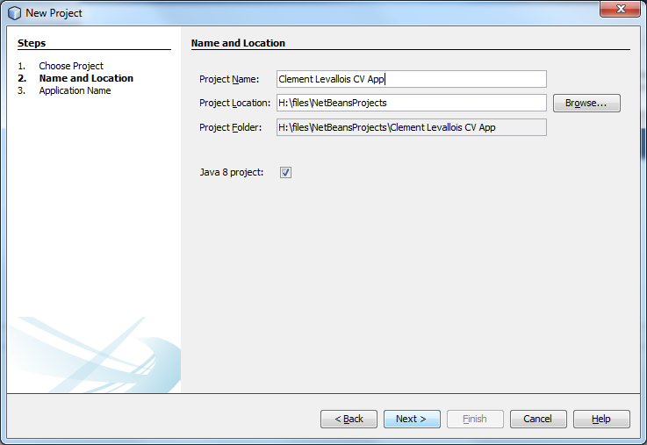

1. Choose a package name, a Theme and a Template

Level of difficulty:   
Estimated time: 5 mn

**Module 1: Installation of useful tools for the course**

*Creating your first project and previewing your app*

Package name : this is the « id card » of your app, it should be unique. How can we find a unique id for an app. The convention is to take the name of your website and reverse it. Like ; if you work at yahoo in France (www.yahoo.fr), you’d have a package name like :

fr.yahoo.myamazingapp.

If you don’t have a website, take a nickname you use on social media or Skype, add a dot and then put the name specific to your app, like:

seinecle.mycv

EMLYON Students : please use the package name **io.codapps**.something, this is to facilitate access to the Apple iOS University program later in the course.

**Final note on packages : use just letters, no space or special characters.**

Then stay on this screen as we need to choose a Theme and a Template

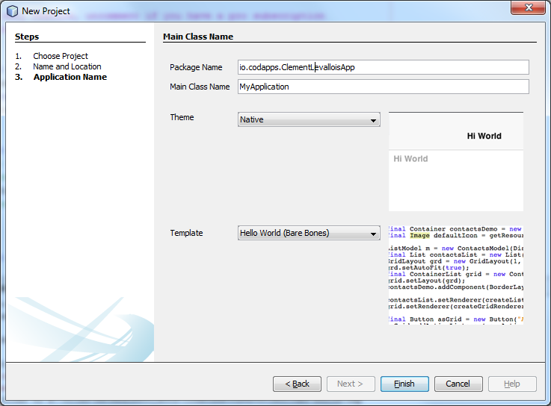

1. A “theme” is how your app will look like (you’ll be able to modify that later).

Level of difficulty:   
Estimated time: 5 mn

**Module 1: Installation of useful tools for the course**

*Creating your first project and previewing your app*

Please choose « **Native** » : this means that your app will have an Apple look on iOS, look like Android style on Android phones, etc.

1. In the template, choose « Hello World **(Bare Bones)** ».

This means that we are going to design our app with the help of the mouse, and also use just a bit of programming (coding!) when necessary.



[**www.codapps.io**](http://www.codapps.io)by Clement Levallois **@codapps_io** [**www.coursera.org/learn/codapps**](http://www.coursera.org/learn/codapps)





1. **Click on « Finish », your first app is ready !**
2. If you don’t see this alert window, you are fine and you have finished this lesson. But if you see it, follow the next steps :

Level of difficulty:   
Estimated time: 5 mn

[**www.codapps.io**](http://www.codapps.io)by Clement Levallois **@codapps_io** [**www.coursera.org/learn/codapps**](http://www.coursera.org/learn/codapps)



**Module 1: Installation of useful tools for the course**

*Creating your first project and previewing your app*

1. Click on « Resolve Problem »

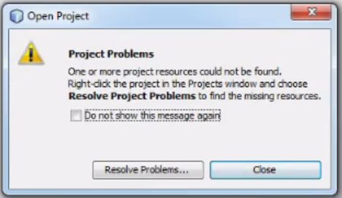

1. A new window opens. Click on « Resolve »

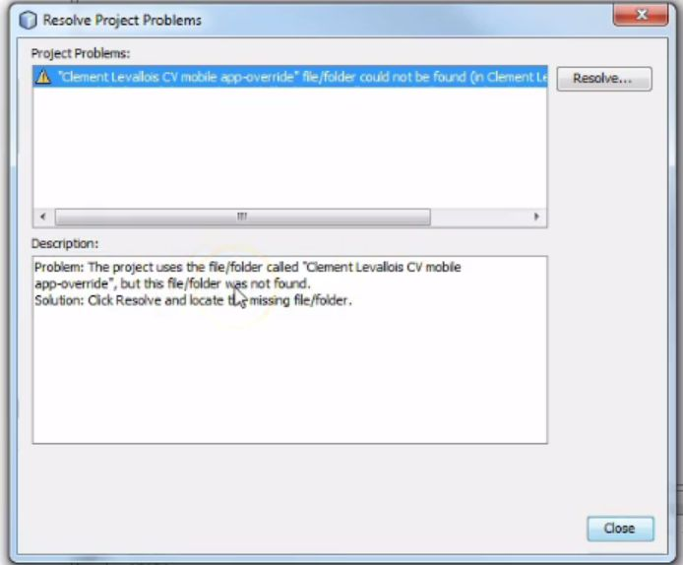

1. A file explorer opens. Open the folder « NetBeans projects »:

[**www.codapps.io**](http://www.codapps.io)by Clement Levallois **@codapps_io** [**www.coursera.org/learn/codapps**](http://www.coursera.org/learn/codapps)



**Module 1: Installation of useful tools for the course**

*Creating your first project and previewing your app*

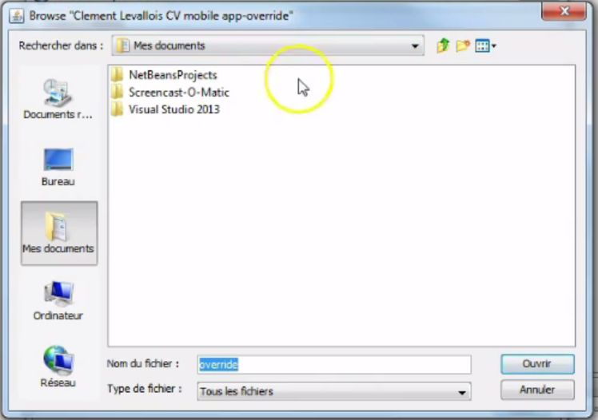

Level of difficulty:   
Estimated time: 5 mn

1. Then open the folder that has the name of the app we just created, and the bug disappears.

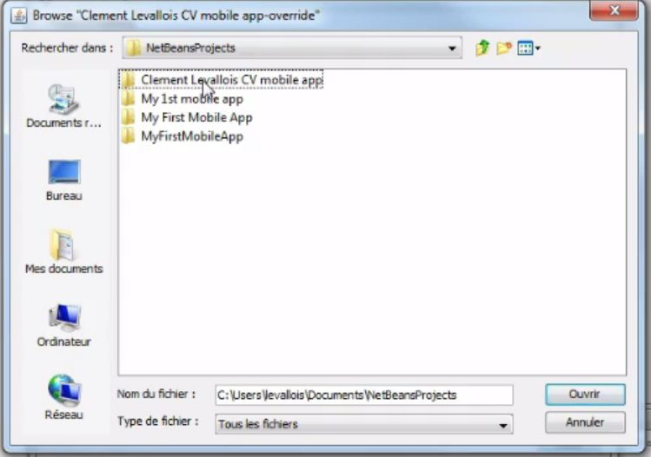*Note: this bug is the only one in the tool we use. After that, we don’t deal with such issues.*

1. Preview your first app! (still empty, but that’s a start!)

[**www.codapps.io**](http://www.codapps.io)by Clement Levallois **@codapps_io** [**www.coursera.org/learn/codapps**](http://www.coursera.org/learn/codapps)



**Module 1: Installation of useful tools for the course**

*Creating your first project and previewing your app*

Level of difficulty:   
Estimated time: 5 mn

* Select your project by clicking on it (it should be highlighted in blue like below)
* Then either:
  + Click on the green arrow (A)
  + Or right click on the project name, and select “run” (B)

You should see your app appear in a new window! It is empty at the moment, but we will learn in the next lessons how to put the content you want in it. And then, how to put in on a mobile phone and on app stores!

